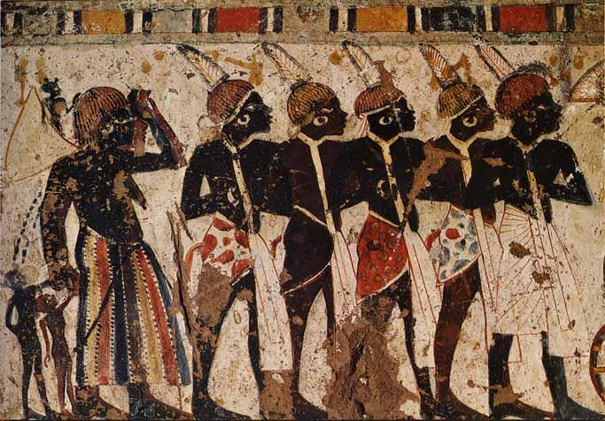
Name
Period
“The Resource-Rich Cultures of Nubia”

Directions: Read pages 85-89 and answer the following questions in COMPLETE SENTENCES in NEAT handwriting.
(30 points total for complete/accurate answers)

- Where is Nubia, exactly? (Be specific when you describe its location) See pages 60, 70, and 86 to get a general idea). Answer in complete sentences.
Nubia is located…..

2. How would you explain the relationship between Nubia and Egypt? (Listen to Ms. Scott’s reading of the chapter and recall and RE-READ the text and think about how war, trade, religion, and culture connected the two civilizations). Answer in complete sentences.

3. List THREE facts (thoroughly, WITH DETAILS and EXPLANATIONS mentioned in the text) about Nubia that hasn’t been mentioned above. Answer in complete sentences. Use the backside of this sheet, as you will need more room.

