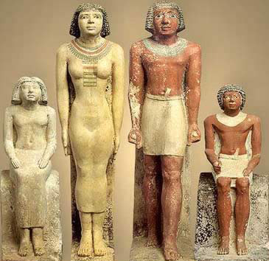
Name Period

“The Culture of the Ancient Egyptians”
DIRECTIONS: Read pages 79-84 and answer the questions IN COMPLETE SENTENCES in NEAT handwriting----in pencil.
You will summarize the sections I ask you to summarize in this chapter.

1. (pg 80) Describe/summarize the system of SOCIAL CLASSES in Egypt in your own words to someone who has NOT read about Egypt.
(I am looking for THOROUGH summarization skills from you after you read the paragraph on page 8o about social classes)

2. (pg 81) Describe/summarize the role of EGYPTIAN WOMEN in your own words to someone who has not read the paragraph about Egyptian Women on page 81.

Turn over for last question---------------------------------->
3. Read pages 81-84, “Achievements of the Egyptians.” Did you read it???? All of it???

What TWO achievements do you think were the most important in Egyptian culture AND WHY were they important?

