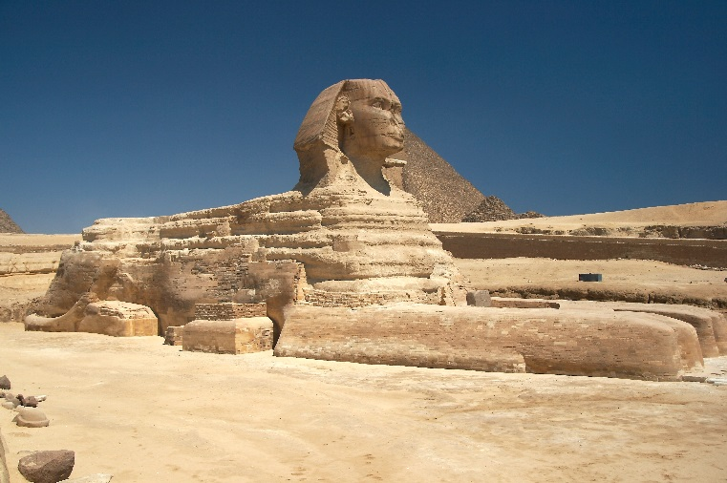
Name_________________________ Period______
Study guide: Egypt Section 3 “Egyptian Religion”

- What were some of the things religion helped explain for the Egyptians? (p. 74)

- What did the Egyptians believe about the afterlife? (p. 75)

- During what period were most of the pyramids built? (p. 77)

- How long could it take to build a pyramid? (p. 77)

- According to the book, how exactly did pyramid builders move the huge stones? (p. 78)

