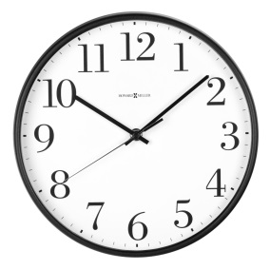
Plan for Egypt Project: Name ______________________________ Period________
Fill out in pencil!!!!
You will need time to research, write out what will be in the text, create images/draw pictures, format and organize how your project looks, and then put it all together.
How will you present your project? (Posters/Scrapbook/Brochure/OR Model or Diorama)

What themes will you cover? (3 REQUIRED)
1
2
3
4 (extra credit)
5 (Extra Credit)
What resources will you use? Where will you get your information from?

Will you handwrite or type the text for your information? (you will need extra time to type—plan for it!)

“ To Do” List for each day (what do you need to do each day in order to get it done ON TIME?)
Friday___________________________________________________________Done?__________
Saturday/Sunday__________________________________________________Done?___________
Monday__________________________________________________________Done?___________
Tuesday__________________________________________________________Done?__________
Wednesday______________________________________________________Done?___________
Thursday________________________________________________________Done?__________
Project is DUE at end of the period on Thursday!!

