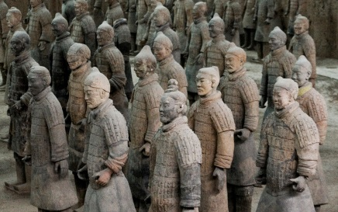
Name_______________________ Period______
Figure 1: The Terra Cotta Army
Chapter 5:3 “Strong Rulers Unite Warrior Kingdoms” Pages 134-139
- What was the “terra cotta army” and what was its purpose?

- Why do YOU think no two statues in the terra cotta army are the same?

- What was SIGNIFICANT about Emperor Shi Huangdi (regarding China’s history--) What was he the first to do?

- Shi Huangdi’s original name was ________________________ and he ruled the _________ Dynasty.
- Shi Huangdi means “________________ __________________.”
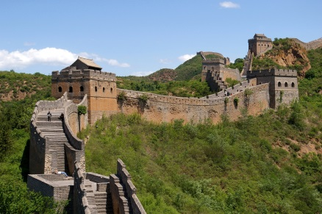
Figure 2: The Great Wall of China
- Why did Shi Huangdi build The Great Wall?

- Did Shi Huangdi build the WHOLE wall?_________________
- How many workers built The Great Wall and how many miles long is it?

- Why did Shi Huangdi have thousands of workers build roads?

10. In the chart, the cycle of the Rise and Fall of Dynasties on page 137, what were the THREE reasons why dynasties grew weak?
1.
2.
3.
11. What is the BENEFIT of having only ONE CURRENCY?

12. What were some ways Shi Huangdi tried to control the thoughts of his people?

13. What was the punishment for disagreeing or protesting against Shi Huangdi? (138)

14. Liu Bang ruled the ________ Dynasty after Shi Huang died and after Shi Huang’s son and grandson failed in ruling the Qin Dynasty.(138-9)
15. Liu Bang was the first ruler in Chinese history who was born a ________________. His rule was less harsh that Shi Huang. (139)
16. _________, the “Warrior Emperor,” was Liu Bang’s great-grandson, and he came into power at _____ years old. His main interest was __________ and _____________ matters.(139)
17. A. How long did it take for the Han Dynasty to fall apart? (139)
B. What happened after the Han Dynasty ended?

18. Why did the HAN Dynasty last longer than the QIN Dynasty? (use those critical thinking skills!)

