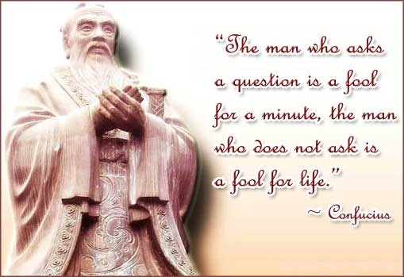
Name______________________ Period____
Chapter 5: Section 2 Pages 129-133
“Confucius and His Teachings”

- Confucius, also known as _________ ___ ___, or “Master Kong,” was one of the most famous –and important—of the early Chinese ___________________.
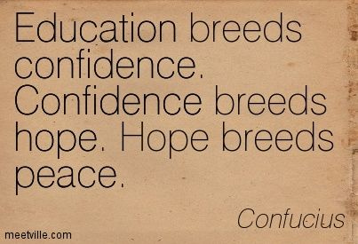
- Confucius loved learning, and he became a ________________.
- What kind of students did Confucius teach?

- When was Confucius born and when did he die?

- What are The Analects? For how long did they serve as a basis of Chinese education?

- What are three things Confucius believed and what was his goal for society?

- Confucius said that in order for society to prosper, people should know their _________ in family and _____________.

- Confucious belived that any person in authority should set a ________ _____________.

- What is the civil service and what does it have to do with Confucius?
- Before Confucius’s ideas, how were government jobs usually assigned (given)?
- After Confucius, how were government jobs assigned?

- After Confucius, what did people have to do in order to get a government job in ancient China?

- Why weren’t some people able to get government jobs?

In your own words, (and in 5 sentences!) SUMMARIZE the main ideas about Confucius that you learned in this chapter. __________________________
_____________________________________________________________
______________________________________________________________
______________________________________________________________
_____________________________________________________________
______________________________________________________________
______________________________________________________________
______________________________________________________________
_____________________________________________________________
______________________________________________________________
_____________________________________________________________

