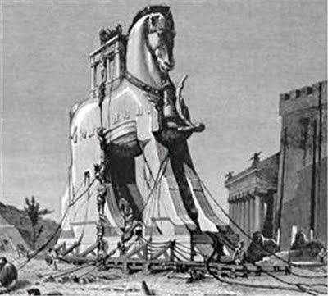
Name__________________________ Period_____
Chapter 6:1 “The Rise of Greek Civilization”
Study Guide

Vocabulary: Write the definition for each word

- Peninsula-

2. Epic-

3. Acropolis-

4. City-state-

5. Aristocrat-

6. Tyrant-

7. Democracy-

8. “___________________ are the major landform of Greece.”

9. How/why did the geography of Greece make it hard for different communities to get together?

10. Each Greek community “developed its own ________________ and _______________.”

11. Why did the Greeks fight each other so much, even though they all shared a common heritage, spoke the same language, and worshipped the same gods?

12. According to Greek mythology, how /why did the TROJAN WAR start?

13. How long was the Trojan War?

14. How did the Greeks eventually win the Trojan War with the “Trojan Horse?” (see box and description on page 155)

15. What poet wrote down the oral traditions (stories) of Greek mythology?

16. What are some reasons why Greece fell into what was known as the “Dark Ages of Greece?” (name at least 3 reasons)
1.

2.

3.

17. What kinds of people ruled the early city-states? EXPLAIN a little bit about what the book says about these people.

18. As Greek trade picked up again, what kinds of people began ruling in place of the aristocracy?

19. Were tyrants always cruel and violent?

20. Look at the picture of the Acropolis in Athens, Greece on page 157. Why would the Athenian people go there during times of attack and invasions?

21. In which Greek city was DEMOCRACY most “fully expressed?”

22. A. What were three laws that the Athenian ruler, Solon, created?
B. Why would these laws have been popular with the Greek citizens?

23. What kinds of people in Athens were NOT able to participate in democracy?

