Name________________________ Period____
Why is the Mesopotamian civilization important/significant to us today?
Science, Mathematics and Technology
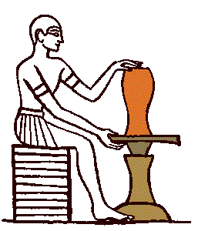
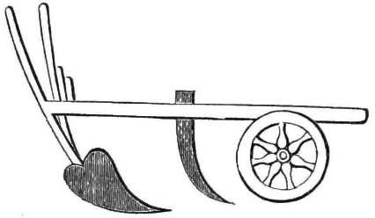
Numerous technological advances can be attributed to the Mesopotamians: irrigation (channeling water for public use and farming), the plow, the sail (for ships), clay bricks, the potters wheel, metal-working (including metal armour and weaponry), writing, accounting, filing, glass and lamp making, weaving and much more. They also developed an impressive body of scientific knowledge through close observation (to inspect closely) of the natural world. Long lists of animals, plants and minerals have come down to us, as well as lists of Geographical features - rivers, mountains, cities and peoples. Plans of cities have been discovered, the most complete one being of Nippur, which matches the maps made by archaeologists. The Mesopotamians also showed a practical grasp of chemical processes in many fields, for example in the preparation of recipes and pigments, and the manufacture (creation) of colored glass.
Potter's wheel
The agricultural plow used for digging into the dirt
Mesopotamian science was particularly fruitful in three areas, mathematics, astronomy and medicine.

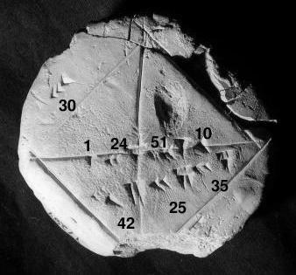
Mathematics
The Mesopotamians developed mathematics to a more advanced level than any contemporary people, and in so doing laid many of the foundations for modern mathematics.

Ancient Mesopotamian clay tablet showing knowledge of Pythagorus' theorem

Mesopotamian scribes (people who write) produced detailed mathematical tables, as well as texts posing advanced mathematical problems. From these we know that they developed a number system based on base 60, which has given us the 60-minute hour, the 24-hour day, and the 360-degree circle. The Sumerian calendar was based on the seven-day week. Their number system, alone in the ancient world, had a place-marker to denote values, as in modern mathematics (as in 3,333 when the number 3 represents 3,000, 300, 30 and 3 respectively).
Geometry: They developed theorems on how to measure the area of several shapes and solids, and came close to an accurate measure of the circumference of circles. They fully understood square roots and cube roots.
This knowledge was not just theoretical. It was applied to the design and construction of large buildings, long aqueducts (water channels) and other ambitious engineering projects.

Astronomy
A major branch of Mesopotamian science was astronomy. Mesopotamian priests produced astronomical tables, and could predict eclipses and solstices. They worked out a 12-month calendar based on the cycles of the moon. Mesopotamian astronomical knowledge was later to have a major influence on Greek astronomy.
As with most pre-modern cultures, astronomy and astrology were closely bound together: the movement of the heavenly bodies were seen as having a direct influence on the activities of men. This was a powerful motivation for priests to work out as exactly as they could the movement of the planets and stars.
Medicine
As in all ancient societies, medicine and religion went hand in hand. Disease was seen as a sign of the gods' displeasure with a person, or even as a manifestation (appearance) of evil spirits dwelling within them. The duty of the doctor was to identify the sin which had caused such displeasure, and to prescribe the correct religious ceremony to bring about healing. Exorcism (getting rid of evil spirits through ritual) commonly recommended.
It is clear, however, that many Mesopotamian doctors mingled (mixed) this approach with a more practical study of the human body and its maladies (sicknesses). Many tablets, (for example a text called the Diagnostic Handbook, dated to 11th century BC in Babylon,) list symptoms (signs of a disease or sickness) and prognoses (prediction of the outcome of the sickness or disease with and without treatment). These show that Mesopotamian doctors had developed rational (science-based and logical) techniques of diagnosis, prognosis, physical examination, and prescriptions alongside the more mystical elements of their trade. Diagnosis and prognosis were based on rules of empirical observation (determined by means of the senses) and logical reasoning (as in modern medicine).
Doctors used bandages, creams and pills in their treatments. This involved a sound (rational) understanding of the properties (characteristics) of different herbs and minerals.
Ancient Mesopotamia's place in World History
Ancient Mesopotamia must surely be the most influential (significant and inspiring others) civilization in world history. For a start, it was the first civilization. The Mesopotamians were the first to build cities, use the potter's wheel, develop writing, use bronze in large quantities, evolve complex bureaucracies, organize proper armies, and so on.
All subsequent (coming after) Western civilizations were ultimately built largely upon foundations (the basic ideas) laid here. Mesopotamian civilization deeply influenced societies in Syria, Palestine and Egypt. These in turn, especially via the Phoenicians and the Israelites, would provide the material, religious and cultural models on which the Greek, Roman and Islamic civilizations would later be constructed. A whole range of technologies and scientific advances were thus made in ancient Mesopotamia which eventually found their way to Medieval and Modern European civilization.
To the east, powerful Mesopotamian influences flowed into India at the time of the Assyrians and Persians - for example, the Sanskrit alphabet is based on the Aramean script.
So, the Mesopotamians built long and well; they were the giants upon whose shoulders later ages have stood. And given that they were the first people to have writing, and the first to record their deeds, their place in world history is, it is no exaggeration to say, as the ones who got it going.
- List the inventions the Mesopotamians developed.

- What were some things regarding MATH that the Mesopotamians developed?

- What medical advances and ideas did the Mesopotamians discover?

- Why was Mesopotamia the most influential civilization in world history?

- What were some of the things the Mesopotamians were the FIRST to do? Find as many things in the text as possible.

