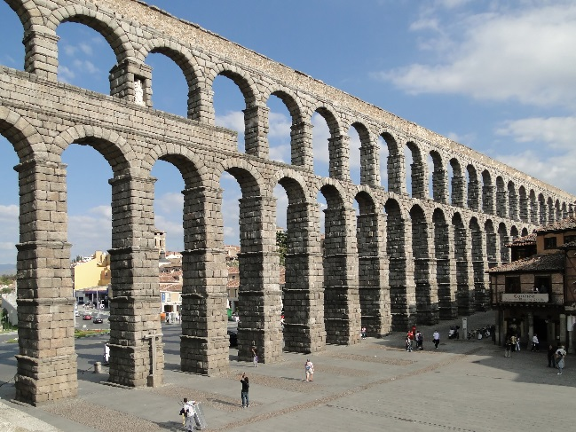
Name__________________________ Period
Figure 1 Ancient Roman Aqueduct
Ancient Rome Study Guide
Chapter 7.2: The Roman Empire
- Province-

- Aqueduct-

Briefly describe the following (who/what were they and why were they important):
- Augustus-

- Hadrian-

- Greece (why was it important to Rome?)-

- Colosseuem-

___________________________________________________________________
- (197) What was a parade called when Roman soldiers returned to Rome victorious? ____________________

- Look at the section, “Augustus, the Senate, and the People.” What are a couple of reasons why the Roman senate liked Augustus?

- Read ALL of the section, “Governing Conquered Peoples.” How did Romans treat the people they conquered? What would Rome do after it conquered others?

- Who were two of the WORST Roman emperors? Why?

- Who was considered the “greatest” emperor according to the text? WHY? (be thorough)

- **(page 199) Which ROMAN language is the SOURCE of French, Italian, Spanish, and Portuguese? ____________________
- (199-200) What were the differences between “Greek and Roman views of learning?”

- “Early art and architecture copied the _____________________. Later the Romans studied and copied _________________ sculpture and architecture.”
- (200) What is the meaning behind the saying, “All roads lead to Rome” ? EXPLAIN.

- Look at the image of the Roman Road on page 201. What are TWO things you find interesting in the picture regarding the technology of the Roman roads and WHY?

