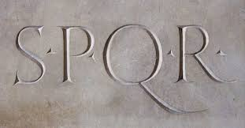
Name_________________________ Period____
Ancient Rome: Study guide
Chapter 7:1—The Roman Republic
p. 191
- Republic-
- Patrician-
- Plebian-
- Consul-
- Veto-
- Dictator-
Briefly describe who/what the following people are and what they did:
- Romulus and Remus-

- Etruscans-

- Julius Caesar-

- Augustus-
- **Cincinnatus-

- ** Servius Tullis-
- What are three things/inventions the Romans took from the Etruscans which helped or at least were a major part of Roman civilization?

- How long did the Roman Republic last?_______________
- What was the conflict that existed between the patricians and the plebeians? (In other words, why didn’t they like each other?)

- Look at the section, “The End of the Republic.” Why wasn’t the consul system working anymore ?

- Gaul was located where __________________ now is. (it’s a modern-day country)
- Was Caesar an emperor or a dictator?________________________
- Why did the Roman senate despise (hate) Ceasar? (what are at least two reasons)

- **Why did the Romans want the republic to have two leaders (consuls) rather than one?

