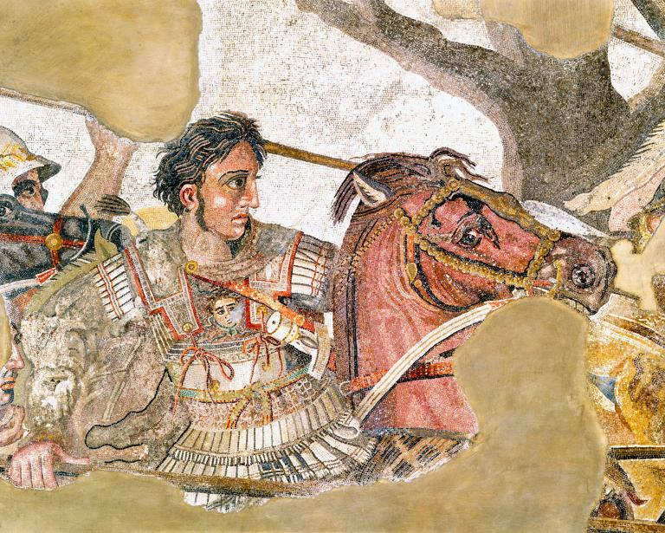
Name__________________________ Period______
6.5 "The Spread of Greek Culture" study guide pgs. 175-179

- Barbarian-

2. Hellenistic-

3. Even though young Alexander, son of Philip of Macedon, thought of himself as being Greek, why didn’t the Greeks consider Alexander and his people GREEK?

4. A. Who was Alexander’s tutor?
B. What belief about the Greeks did this tutor teach Alexander?

5. What important thing did King Philip of Macedon do? Why was this SIGNIFICANT?

6. Why did Alexander assume his father’s throne at 20 years old? What happened to King Philip?
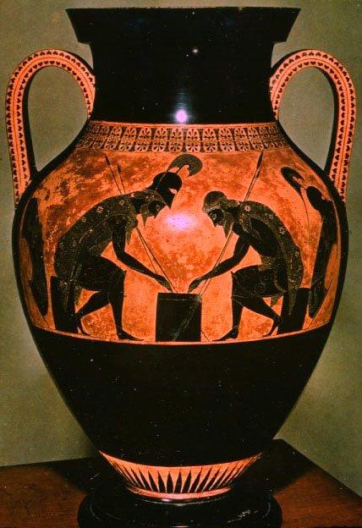

7. Who was Alexander’s mythological hero?

8. Alexander “the GREAT”: How long did it take Alexander to conquer Persia, Egypt, and “lands extending beyond the Indus River in the East?”

9. A. After Alexander’s death, what happened to the VAST empire he had established?
B. Why do you think this happened? (Remember what I said about IMPERIALISM and what SPARTA and ROME did--and what our country is pretty much still doing today---one of your group will need to look this up online!)

10. Read the section on “Hellenistic Kingdoms” on page 177 CLOSELY.
HOW were the Hellenistic cities (which Alexander had conquered outside of Greece) modeled after Greek cities?

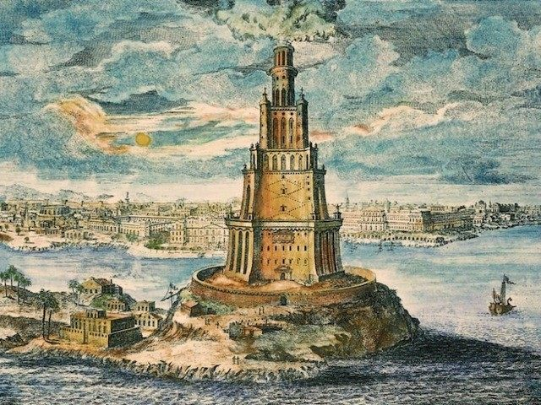
11. A. What city was the GREATEST of all Hellenistic cities?
B. Name as many reasons as you can find as to WHY this city was so important.

12. What did many ancient Greek scientists believe about the earth before COLUMBUS?

13. What did the Greek scientist ERATOSTHENES do?

14. What did the Greek scientist ARCHIMEDES do? (see also the pictures and descriptions on pg 179).

