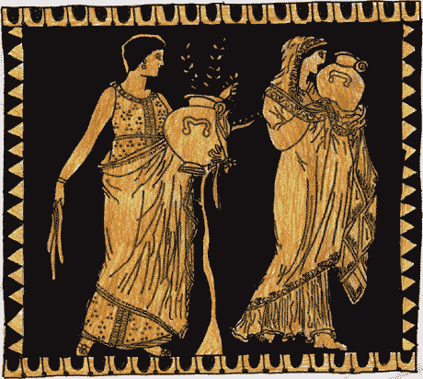
Name____________________________ Period_______
6.3 "Daily Life of the Ancient Greeks" study guide pgs. 165-169

- How would young students record their lessons when they went to school?

2. A. What was the “Agora” in Ancient Athens?
B. What kind of activities would happen there?

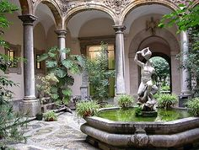

3. What was found in the center of houses in Greece?

4. A. How many slaves might Ancient Athens have had?
B. How much of the population in Athens did slaves make up?
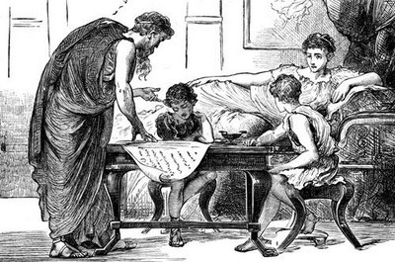

5. A. Where did ancient Greeks get their slaves?
B. Why weren’t there many GREEK slaves?
C. What kind of slaves had the easiest lives?
D. What kind of slaves had the hardest lives?

6. A. Where did Athenian women spend most of their time? B. WHY?

7. What kinds of jobs did Athenian women do?

***8. Now go online and look up “Hypatia” (a female Greek philosopher)
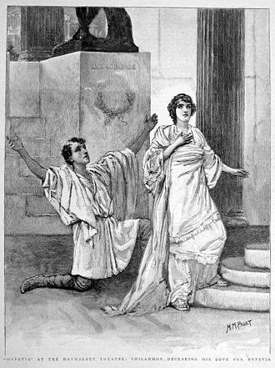
- When was she born?

B. When did she die?

C. Where did she teach?

D. What did she teach?

E. Why was she special? (Why wasn’t she like normal Greek women?)

F. How did she die and why was her death important?

